Phenological Trends with Remote Sensing Datacubes
06 June 2024

Authors:
E. Shayle (1), M. Marcantonio* (2), R. Labadessa (3), C. Richiardi (4), & S. Vicario (3)

Affiliations:
- Environmental Informatics, University of Marburg, Deutschhausstr. 12 - 35032, Marburg, Germany
- Landlife Ecospatial Labs, Via Del Giontech, 1, Mezzocorna (TR), Italy
- CNR - IIA, Via Orabona, 4, Bari, Italy
- ENEA, Strada per Crescentino, 13, Saluggia (VC), Italy
* Corresponding author: marcantoniomatteo@gmail.com

Keywords:
Rao’s Q Index, Time-Weighted Dynamic Time Warping, Landscape Heterogeneity, Remote Sensing, Time Series, Phenology

Dirk’s Notes:
Here is the coarse structure of the story of the whole manuscript. Of course this is mirrored in the abstract:
Problem. One general sentence setting up the scene, maybe something with phenological variation, spatio-temporal dynamics, and that these are operationalized via biodiversity indices. Then more specific: "Biodiversity indices like Shannon’s H do not consider spatio-temporal dynamics, and others (e.g. Rao’s Q) only incorporate geographic distance between observations, often leaving phenological variation overlooked." What follows from this problem? Phenological variation is by default ignored? Why is this a problem? Is there literature describing this problem? Is misclassification (as mentioned in the potential solution that follows) of plant communities the main issue or are there also other issues?
Potential solution. "We compared the ability of TWDTW Rao’s Q index against other biodiversity indices at classifying different plant communities"
Methods: Here we need to decide for an experimental setup (=which sites/scales/data whatsoever can be used to test the potential solution. Then these data are described. Then the statistics are described to come up with an answer for “compare the ability of TWDTW Rao’s Q index against other biodiversity indices”
Results. The boring numbers from the statistics. The pitch that the method is already implemented in the rasterdiv package. Then the boring numbers are interpreted:
Conclusions: "Accounting for phenological cycles can filter out artefacts and better distinguish habitats with differing plant species diversity." "This improves the ability to assess ecosystem changes through space and time, providing a more comprehensive understanding of biodiversity dynamics, and the ability to gauge the resilience of different vegetation patches."

Table of Contents
Dirk’s Notes: 1
Preprint Abstract: 3
Preprint Introduction: 4
The Importance of Biodiversity Indices: 4
The Purpose of (Time-Weighted) Dynamic Time Warping & its Ecological Utility: 5
Postprint Introduction: 6
Preprint Case Study & Results: 8
Implementation within rasterdiv: 8
Study Site Description & Plant Biodiversity Data: 9
Efficacy Evaluation of our Results: 10
Postprint Methodology: 12
Study Sites: 12
Data Preprocessing: 12
Analytical Approach: 12
Postprint Results: 12
Distinguishing Land-use Types in Macchia Sacra: 12
Monitoring Rewilding of the Knepp Estate: 13
Assessing Land-use Type Diversity in Kilimanjaro National Park: 13
Preprint Discussion: 13
Postprint Discussion: 14
Preprint Conclusion: 14
Postprint Conclusion: 14
Preprint GitHub & Data Repositories: 14
Preprint Acknowledgements: 14
References: 15

Preprint Abstract:
During the 2024 B-Cubed Hackathon, we extended the R package “rasterdiv” by incorporating Time-Weighted Dynamic Time Warping (TWDTW) to the package’s pre-existing paRao() function for the calculation of parametric Rao’s Quadratic Diversity (Rao’s Q) index. This expands the user’s ability to biodiversity trends when using time series of Earth Observations. Biodiversity indices like Shannon’s H do not consider spatio-temporal dynamics, and others (e.g. Rao’s Q) only incorporate geographic distance between observations, often leaving phenological variation overlooked.
Through integrating TWDTW into the paRao() function, users can assess different facets of an ecosystem’s biodiversity by incorporating phenological differences among its plant communities. This is also valuable to distinguish between natural habitats that follow a seasonal phenological trend and artificial land cover types, which may lack phenological changes. Previous studies have also found that the time weighting ability of TWDTW enables the discernment of different floral community types which could otherwise be misclassified as the same with traditional Dynamic Time Warping (DTW).
To evaluate the efficacy of TWDTW within the paRao() function, we compared the ability of TWDTW Rao’s Q index against other biodiversity indices at classifying the different plant communities in a disturbed grassland in Calabria, Italy. Our study used a Plant Phenological Index (PPI) time series from the Sentinel-2 satellite network. The results indicated that accounting for phenological cycles can filter out artefacts and better distinguish habitats with differing plant species diversity. This improves the ability to assess ecosystem changes through space and time, providing a more comprehensive understanding of biodiversity dynamics, and the ability to gauge the resilience of different vegetation patches.
We conclude that the inclusion of plant phenology in biodiversity assessment is necessary, and that our modifications to paRao() will be valuable to facilitate the accurate detection and description of ecosystem trends in response to our changing environment.

Preprint Introduction:
The B-Cubed Hackathon brought together computer scientists and ecologists from a variety of institutions to rapidly create novel informatics solutions to the biodiversity challenges facing the planet. We identified that the addition of time-weighting to the R package “rasterdiv” would be a worthwhile contribution to the environmental informatics community. rasterdiv was created to calculate biodiversity indices from numerical matrices in the R programming environment.
Biodiversity indices included in rasterdiv currently focus on the spatial component. Here we outline how our extension to the pre-existing implementation of Rao’s Q diversity indices (Rocchini, Marcantonio, and Ricotta 2017) can explicitly account for the temporal dimension of data, alongside the relevant biological context to our extension.

The Importance of Biodiversity Indices:
Ecosystems with heterogeneous biota have been shown both experimentally and theoretically to provide greater utility to all the agents which comprise that ecosystem (Zhang et al. 2022). This is through the provision of more resources and a greater variety of niches available for species. This subsequently increases the value of ecosystem services provided to the people in communities surrounding an ecosystem. Heterogeneous ecosystems are typically also more resilient to disturbances they experience, likely because they have functional redundancy (Mace, Norris, and Fitter 2012). Due to the centrality of biodiversity to healthy ecosystem functioning, quantitative measures of biodiversity are required to understand how ecosystems are responding to ongoing environmental changes, such as shifting land use patterns and climate change.
Novel satellite remote sensing tools generate large amounts of data about the Earth’s surface at increasing rate, due to their almost constant temporal coverage and increasing spatial resolution (Frazier and Hemingway 2021). The “big data” generated by these systems need to be interpreted effectively to accurately detect and describe ecosystem trends, such as a change in ecosystem diversity. Consequently, information theory has been used to build the analytical tools which are now regularly used to assess remote sensing datasets. For example, Shannon’s H index, and other related indices only based on mathematical transformation of frequency data, have been widely used as a proxy for biodiversity. But these can be inadequate when applied to time series data generated by remote sensing platforms. In fact, these indices do not consider the distance between each sampled point (whether they are species incidences, pixels, or any other quantitative abstractions of an observation). This approach therefore treats all objects within a dataset as equidistant from one another, so measures of Shannon’s H value are prone to saturation, especially when only marginal differences are observed between the objects in a remote sensing dataset.
Rao’s Quadratic Diversity index (Rao’s Q) adds “space” (but not necessarily geographical space) as a trait to its abstraction of biodiversity by accounting for the distance between traits of the observations within a study site. As a trait informed alternative to Shannon’s H, Rao’s Q has been demonstrated experimentally to offer greater efficacy when representing biodiversity in aerial remote sensing datasets (Rocchini et al. 2021), for which pixels are the discrete observation unit. However, Rao’s Q remains limited by its inability to assess trait change over time. Current implementations of the index (for example in the rasterdiv R package (Rocchini et al. 2021)) only assess one snapshot of the data at a time. We set out to overcome this limitation by incorporating Time-Weighted Dynamic Time Warping (TWDTW) to include time as a component of the distance variable within Rao’s Q.

The Purpose of (Time-Weighted) Dynamic Time Warping & its Ecological Utility:
Dynamic Time Warping (DTW) is a mathematical approach used to compare data series when the timing of observations differs. It has been used in a variety of disciplines. DTW works by finding the smallest distance between two time series.
However, by minimising the differences in timing, biologically significant differences can also be obscured, such as when comparing plant phenology. For instance, many tree species require a minimum number of Growing Degree Hours (GDH) to commence their springtime budburst (Fu et al. 2019). Many other ecosystem processes, such as seasonal migrations and pollination, need to coincide with phenological events, so phenology timing represents an important differentiating factor for time series representing ecosystems with plants (Fitchett, Grab, and Thompson 2015).
The TWDTW approach rectifies this by imposing a “cost” when aligning observations (which in our study are pixels) with greater temporal separation. Therefore, the TWDTW function is less likely to match a time series to others which exhibit substantially different phenologies. This has been successfully demonstrated by Maus et al (V. Maus et al. 2016) to classify changing land use patterns in the Brazilian Amazon, and was a more effective tool than standard DTW when applied to heterogeneous biological environments like these.
In addition to the standard cost matrix of the DTW function, they also propose a method to implement a cost due to temporal separation of temporal trends (Equation 1). In Equation 1, $α$ is the steepness of the logistic function which is used to impose a distance penalty on temporal separation, and $β$ is the midpoint of the curve, the threshold below which separation in time does not substantially impact the other components of the equation. Lastly, $g\left(t_{i},t_{j}\right)$ represents the time elapsed between the dates evaluated in the match ($t_{i}$ and $t_{j}$ times of the $i$^{th} and $j$^{th} observations respectively).
$$ω_{i,j}=\frac{1}{1+e^{-α\left(g\left(t_{i},t_{j}\right)-β\right)}}$$
In this manuscript, we used Copernicus Sentinel-2 mission’s optical data of a small, grazed grassland site in Calabria, Italy to demonstrate and evaluate our R-based rasterdiv implementation of phenology into Rao’s Q index. We also evaluated its efficacy in comparison to the Shannon’s H and unmodified Rao’s Q indices.

Postprint Introduction:
Ecosystems with heterogeneous biota have been shown both experimentally and theoretically to provide greater utility to all the agents which comprise that ecosystem (Zhang et al., 2022) due to the provision of more resources and a greater variety of niches available for species. This subsequently increases the value of ecosystem services provided to the people in communities surrounding an ecosystem. Heterogeneous ecosystems are typically also more resilient to disturbances they experience, likely because they have functional redundancy (Mace et al., 2012). Due to the centrality of biodiversity to healthy ecosystem functioning, quantitative measures of biodiversity are required to understand how ecosystems are responding to ongoing environmental changes, such as shifting land use patterns and climate change.
Biodiversity is inherently spatio-temporal: species composition, abundance, and ecological functions fluctuate throughout both space and time. However, the analytical tools most widely used to quantify biodiversity often treat ecosystems as temporally fixed (Botta-Dukát, 2005; Shannon, 1948). Traditional biodiversity indices, such as Shannon’s H and Simpson’s Diversity Index, capture variation in community composition, but overlook the spatial or temporal distances among observations (Shannon, 1948; Torresani et al., 2019). This omission limits their capacity to represent ecosystems which seasonally fluctuate, such as forests, which typically change in response to the phenological cycles of their constituent plant communities (Torresani et al., 2019). When phenological variation is ignored, valuable ecological insights can be missed, and distinct habitats may be misclassified as similar despite the presence of meaningful biological differences (Maus et al., 2016; Shayle et al., 2024).
Satellite remote sensing now provides near-continuous coverage of the Earth’s surface at high spatial and temporal resolutions, offering new opportunities to monitor ecological processes across scales (Klosterman et al., 2014; Pettorelli et al., 2014). Time-series data from sensors such as Copernicus Sentinel-2 or PlanetScope enable direct observation of plant phenology through indices like NDVI or the Plant Phenology Index (PPI). However, the effective use of these data will, in whole or in part, depend on the availability and ease-of-use of methods which can make meaning from the maths. Some traditional approaches used in remote sensing are limited when applied to time-series data as they assume all observations are equidistant. This can lead to a phenomena known as index saturation (reference), and consequently, the loss of discriminatory power, especially when ecosystems differ more in their seasonal timing than in their mean spectral properties.
Rao’s Quadratic Diversity index (Rao’s Q) offers a more flexible basis for biodiversity quantification because it incorporates dissimilarities among observations, whether spatial, spectral, or functional (Torresani et al., 2019). By introducing a distance matrix into its formulation, Rao’s Q measures diversity as the expected dissimilarity between pairs of sampling units (Rocchini et al., 2017). This allows it to capture trait-based or spatial heterogeneity within a landscape, and it has proven effective for quantifying biodiversity from remote-sensing data using pixels which function as discrete observation units. Yet despite this advantage, typical implementations of Rao’s Q remain limited to single temporal snapshots (Madonsela et al., 2017; Rocchini, 2007). They therefore overlook changes in ecological traits through time, which is precisely the information inherent to phenological dynamics.
Variation in the timing and amplitude of vegetative cycles reflects the underlying community composition and millennia of environmental adaptations (Fu et al., 2019), influencing ecological resilience and the provision of ecosystem services (Mace et al., 2012). Quantifying this temporal diversity requires comparing time-series trajectories in a way that recognises both amplitude and timing differences. Dynamic Time Warping (DTW) provides a framework for comparing such series by aligning them even when their phenological phases differ. However, by fully minimising phase differences, standard DTW can obscure biologically significant timing offsets such as those driven by species-specific responses to temperature or moisture.
Time-Weighted Dynamic Time Warping (TWDTW) addresses this limitation by introducing a temporal weighting function that penalises large timing discrepancies between observations (Maus, 2023; Maus et al., 2016). In doing so, it discourages biologically unrealistic alignments and preserves ecologically meaningful differences in phenological timing. This approach has already demonstrated strong potential in ecological and remote-sensing contexts. For instance, (Maus et al., 2016) applied TWDTW to classify changing land-use patterns in the Brazilian Amazon, where standard DTW frequently misclassified land being used for crop production as being part of the Amazon rainforest. By incorporating time weighting, TWDTW achieved greater accuracy in distinguishing land-cover types by accounting for the distinct phenological cycles of these ecosystems (Maus et al., 2016). These findings highlight the importance of including phenological information when interpreting time-series data: ecosystems or land uses that may appear spectrally similar at individual time points can exhibit profound functional differences throughout time (Torresani et al., 2019). Consequently, incorporating temporal distance into biodiversity assessments has clear value for improving ecological inference and classification accuracy (Rocchini et al., 2021).
Here, we demonstrate the recent addition of TWDTW to Rao’s Q (Shayle et al., 2024), enabling the quantification of phenological diversity from remotely sensed time-series data. By embedding temporal dissimilarity directly into the Rao’s Q’s distance matrix, our approach integrates both spatial and temporal facets of ecosystem heterogeneity. Herein, we evaluate the performance of this phenologically-informed Rao’s Q across three ecologically distinct landscapes:
- the Macchia Sacra conservation area in southern Italy, a Mediterranean mosaic of natural and agricultural land uses;
- the Knepp Estate in the United Kingdom, a leading rewilding project exemplifying ecosystem recovery and dynamic succession; and
- Mount Kilimanjaro National Park in Tanzania, a tropical biodiversity hotspot spanning strong environmental gradients.
Together, these case studies provide a robust test of the method’s capacity to detect and interpret phenological diversity across contrasting biomes, land-use regimes, and spatial scales. By combining Rao’s Q with TWDTW, we offer a generalisable framework available to any user of R for analysing biodiversity as a spatio-temporal property of ecosystems, improving our ability to monitor ecological change from space.

Preprint Case Study & Results:

Implementation within rasterdiv:
We implemented this method within the existing paRao() function of the rasterdiv R package (Marcantonio, Thouverau, and Rocchini 2024). We used the twtwd function from the twdtw R package (Victor Maus 2023) which is a wrapper for C++ implementations of TWDTW functions. In particular, the twtwd method was implemented through the internal hidden function .mtwdtw:
.mtwdtw <- function(x, time_vector = 0, stepness = -0.5, midpoint = 35, cycle_length = "year", time_scale = "day") {
twdtw::twdtw(
x = data.frame(time = time_vector, v = x[[1]]),
y = data.frame(time = time_vector, v = x[[2]]),
time_weight = c(stepness = stepness, midpoint = midpoint),
cycle_length = cycle_length,
time_scale = time_scale)
}
stored in the rasterdiv file mdist.R. The paRao() function uses the "distm_m" argument to internally call this function, applying it to pairwise pixel time series (Z). Within each moving window, Rao’s Q index is calculated using the computed distances and the specified alpha value. By leveraging the TWDTW distance over a time-series of matrices or images, Rao’s Q index can be calculated using the following R function:
paRao(x = time.series,
time_vector = time,
window = 3,
alpha = 2,
na.tolerance = 0,
simplify = 3,
method = "multidimension",
dist_m = "twdtw",
midpoint = 35,
stepness = -0.5
)
The arguments and our input parameters of which are:
time.series is an (X, Y, Z) raster stack (or “cube”) of spectral data, where the X and Y axes represent discrete pixel values, and each layer of the Z axis is a a different temporal snapshot of the raster layer. In our study, this is the Sentinel-2 derived time series (with daily Z temporal resolution) of our study site.
time_vector A vector of dates corresponding to every Z layer in the raster time series, which must be the same as the Z axis from the x variable. All pixels in the input time series must share the same temporal spacing as the temporal pattern to which it is being compared (i.e. if the time series has observations on days c(1, 3, 7, ...), then the pattern it is being compared to must also have observations on days c(1, 3, 7, ...). If any x, y pixel i along the Z temporal vector has any invalid numeric data (e.g., NA, NULL, Inf, etc.), its Rao’s Q index value will be NA, since DTW does not allow for no data values.
steepness A continuous numeric value corresponding to the $α$ variable from the time-weighting function in Maus et al (V. Maus et al. 2016). Different values of $α$ can increase or decrease penalisation for deviations from the pattern time.
midpoint A numeric value corresponding to the $β$ variable from the time-weighting function in Maus et al (V. Maus et al. 2016). The input data must be of the unit specified by the time_scale argument (e.g. in our example, it is expressed in days).
cycle_length This argument indicates the length of a single cycle. This argument can accept either a string or numeric value. Valid string input values are “year”, “month”, “day”, “hour”, “minute”, and “second”. String inputs are also passed to the time_scale argument. Numeric input values must be the same unit specified by the time_scale argument.
time_scale This argument sets the units of the TWDTW function’s cycle length. Valid string input values are “year”, “month”, “day”, “hour”, “minute”, and “second”. If the input given to cycle_length is a string value, then this argument will change the units given in the output. Alternatively, if a numeric value is given to cycle_length, then this argument will compute the elapsed time in seconds.
Other arguments remain unchanged from (Victor Maus 2023).

Study Site Description & Plant Biodiversity Data:
The study site was a small (6 hectare) area within the protected area of “Macchia Sacra” (Site of Community Importance (SCI): SICIT9310073). It was selected as it was suitable for thorough imaging by drone, which formed the basis of our ground-truthed biodiversity observations. After drone image acquisition, we defined eight types of plant communities within the study site, with the expertise in classification imparted by an expert botanist (Figure 1). The study site is characterized by the presence of a road on the north-east part of the site. From the level of the road the elevation declines to a lower part which features a sharp canyon running south to west, the result of a previous small stream which had dried up by the time of our drone survey. This part of the study site is characterized by hydrophilic vegetation. Between these two extremes is a small hill which culminates in a plateau. The plateau is the resting area of a herd of cows which graze in the area. This area is much dryer and subject to strong pasture pressure and mechanical disruption, but is more nutrient which, due to the presence of cow manure.
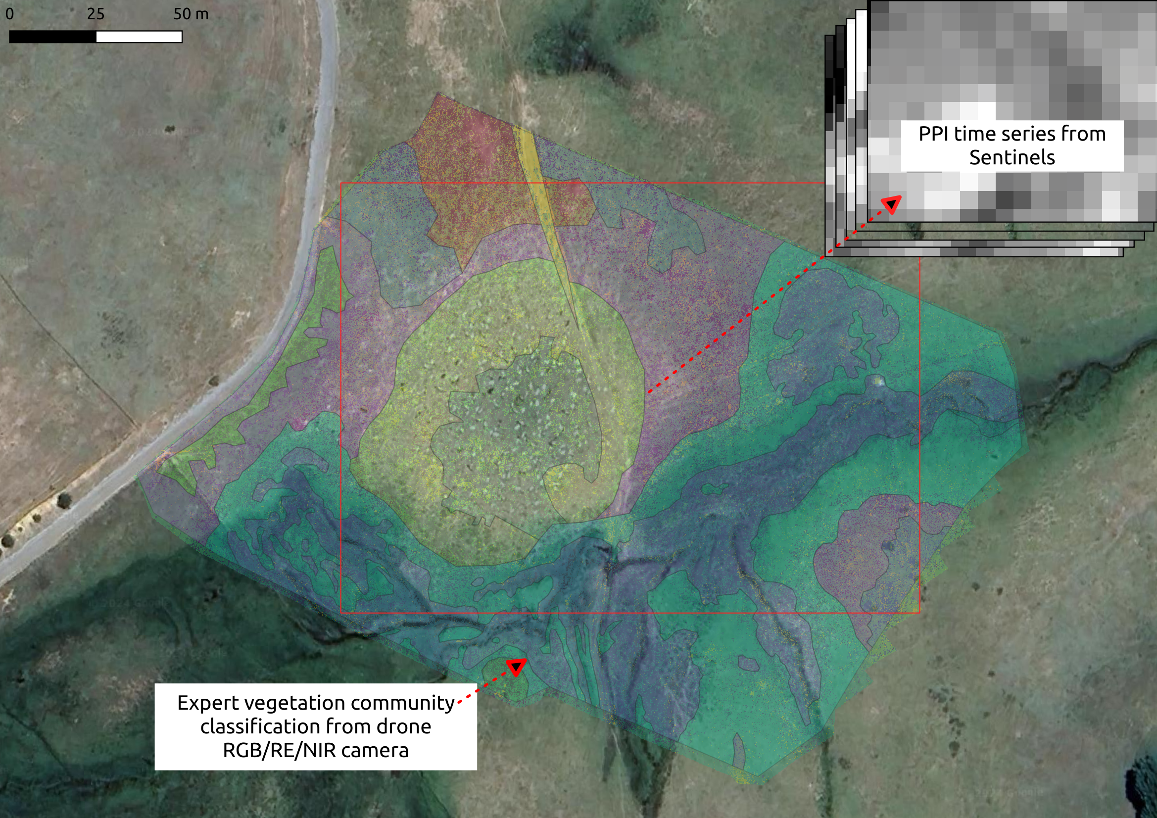
Figure 1: A true colour RGB satellite image (Map data: Google, Maxar Technologies 2023) giving an overview of the study site and its surroundings within Calabria. The eight different plant community types are overlaid as differently coloured masks in transparency upon the image. The subset of the study site which was extracted from Sentinel-2 data is indicated within the red rectangle.

Efficacy Evaluation of our Results:
We used a time series of 144 Plant Phenological Index (PPI) images derived from Sentinel-2 imagery and available through the Copernicus Service High Resolution Vegetation Phenology and Productivity (HRVPP) (data acquired via: https://scihub.copernicus.eu/) encompassing all data which were available in 2023 (Figure 2). The dimensions of each image were 20 pixels vertically by 27 pixels horizontally, and each pixel was 10m². The PPI index was chosen as it is minimally influenced by soil signal and the presence of shadows (Karkauskaite, Tagesson, and Fensholt 2017).
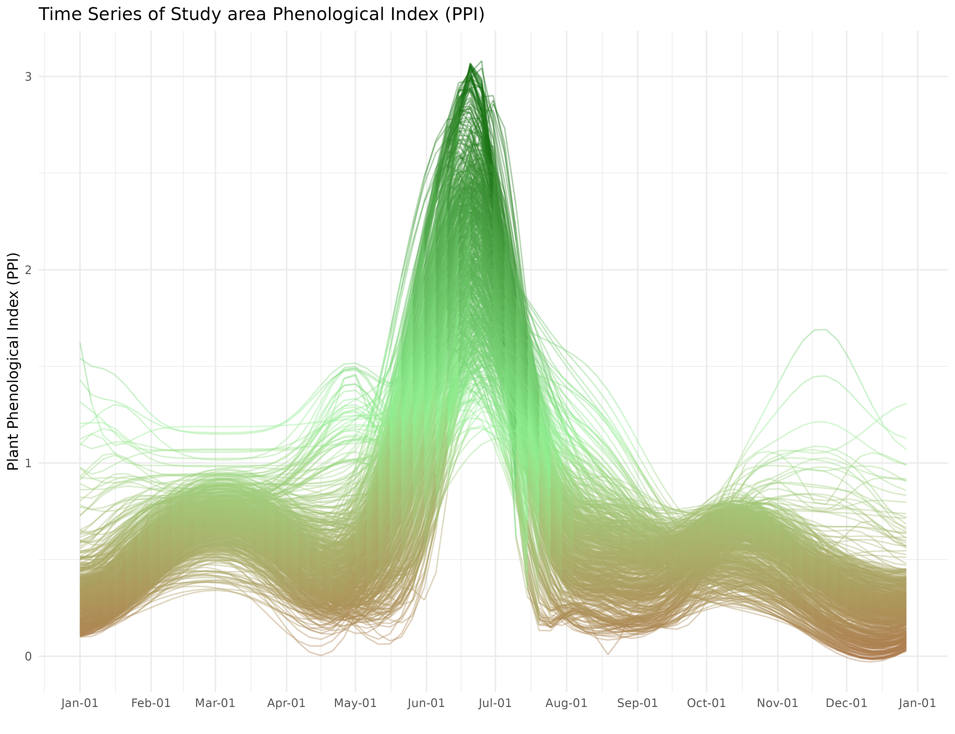
Figure 2: A time series illustrating changes in the value of the Plant Phenological Index (PPI) for every pixel within the Macchia Sacra Special Protection Area study site in Calabria.
Using these data, we applied three analytical approaches to measure biodiversity: i) The Shannon’s Biodiversity index applied to the mean yearly PPI trajectory, ii) the classical Rao’s Q index, applied to the same dataset and with three digits numeric resolution, and iii) the Rao’s Q index with our implementation of the TWDTW function across the full time series of 144 images. A gross visual inspection of Figure 3 illustrates the unsuitability of Shannon’s H index, as when using a 3 pixel wide moving window, all pixels inside each window exhibited different values and the index was always equal to its maximum (i.e., $ln\left(S\right)$). It was therefore impossible to classify the ecosystem into different groups. The standard Rao’s Q index identified the main biodiversity hotspot as where the road intersects with the study site, and a secondary hotspot as the plateau atop the hill. Finally, our new implementation of Rao’s Q index with the DTW distance metrics resulted in two meaningful differences from the standard Rao’s Q index: the road is no longer a “diversity” hotspot, and the main biodiversity hotspot moved to the borders between two of the communities identified by our expert.
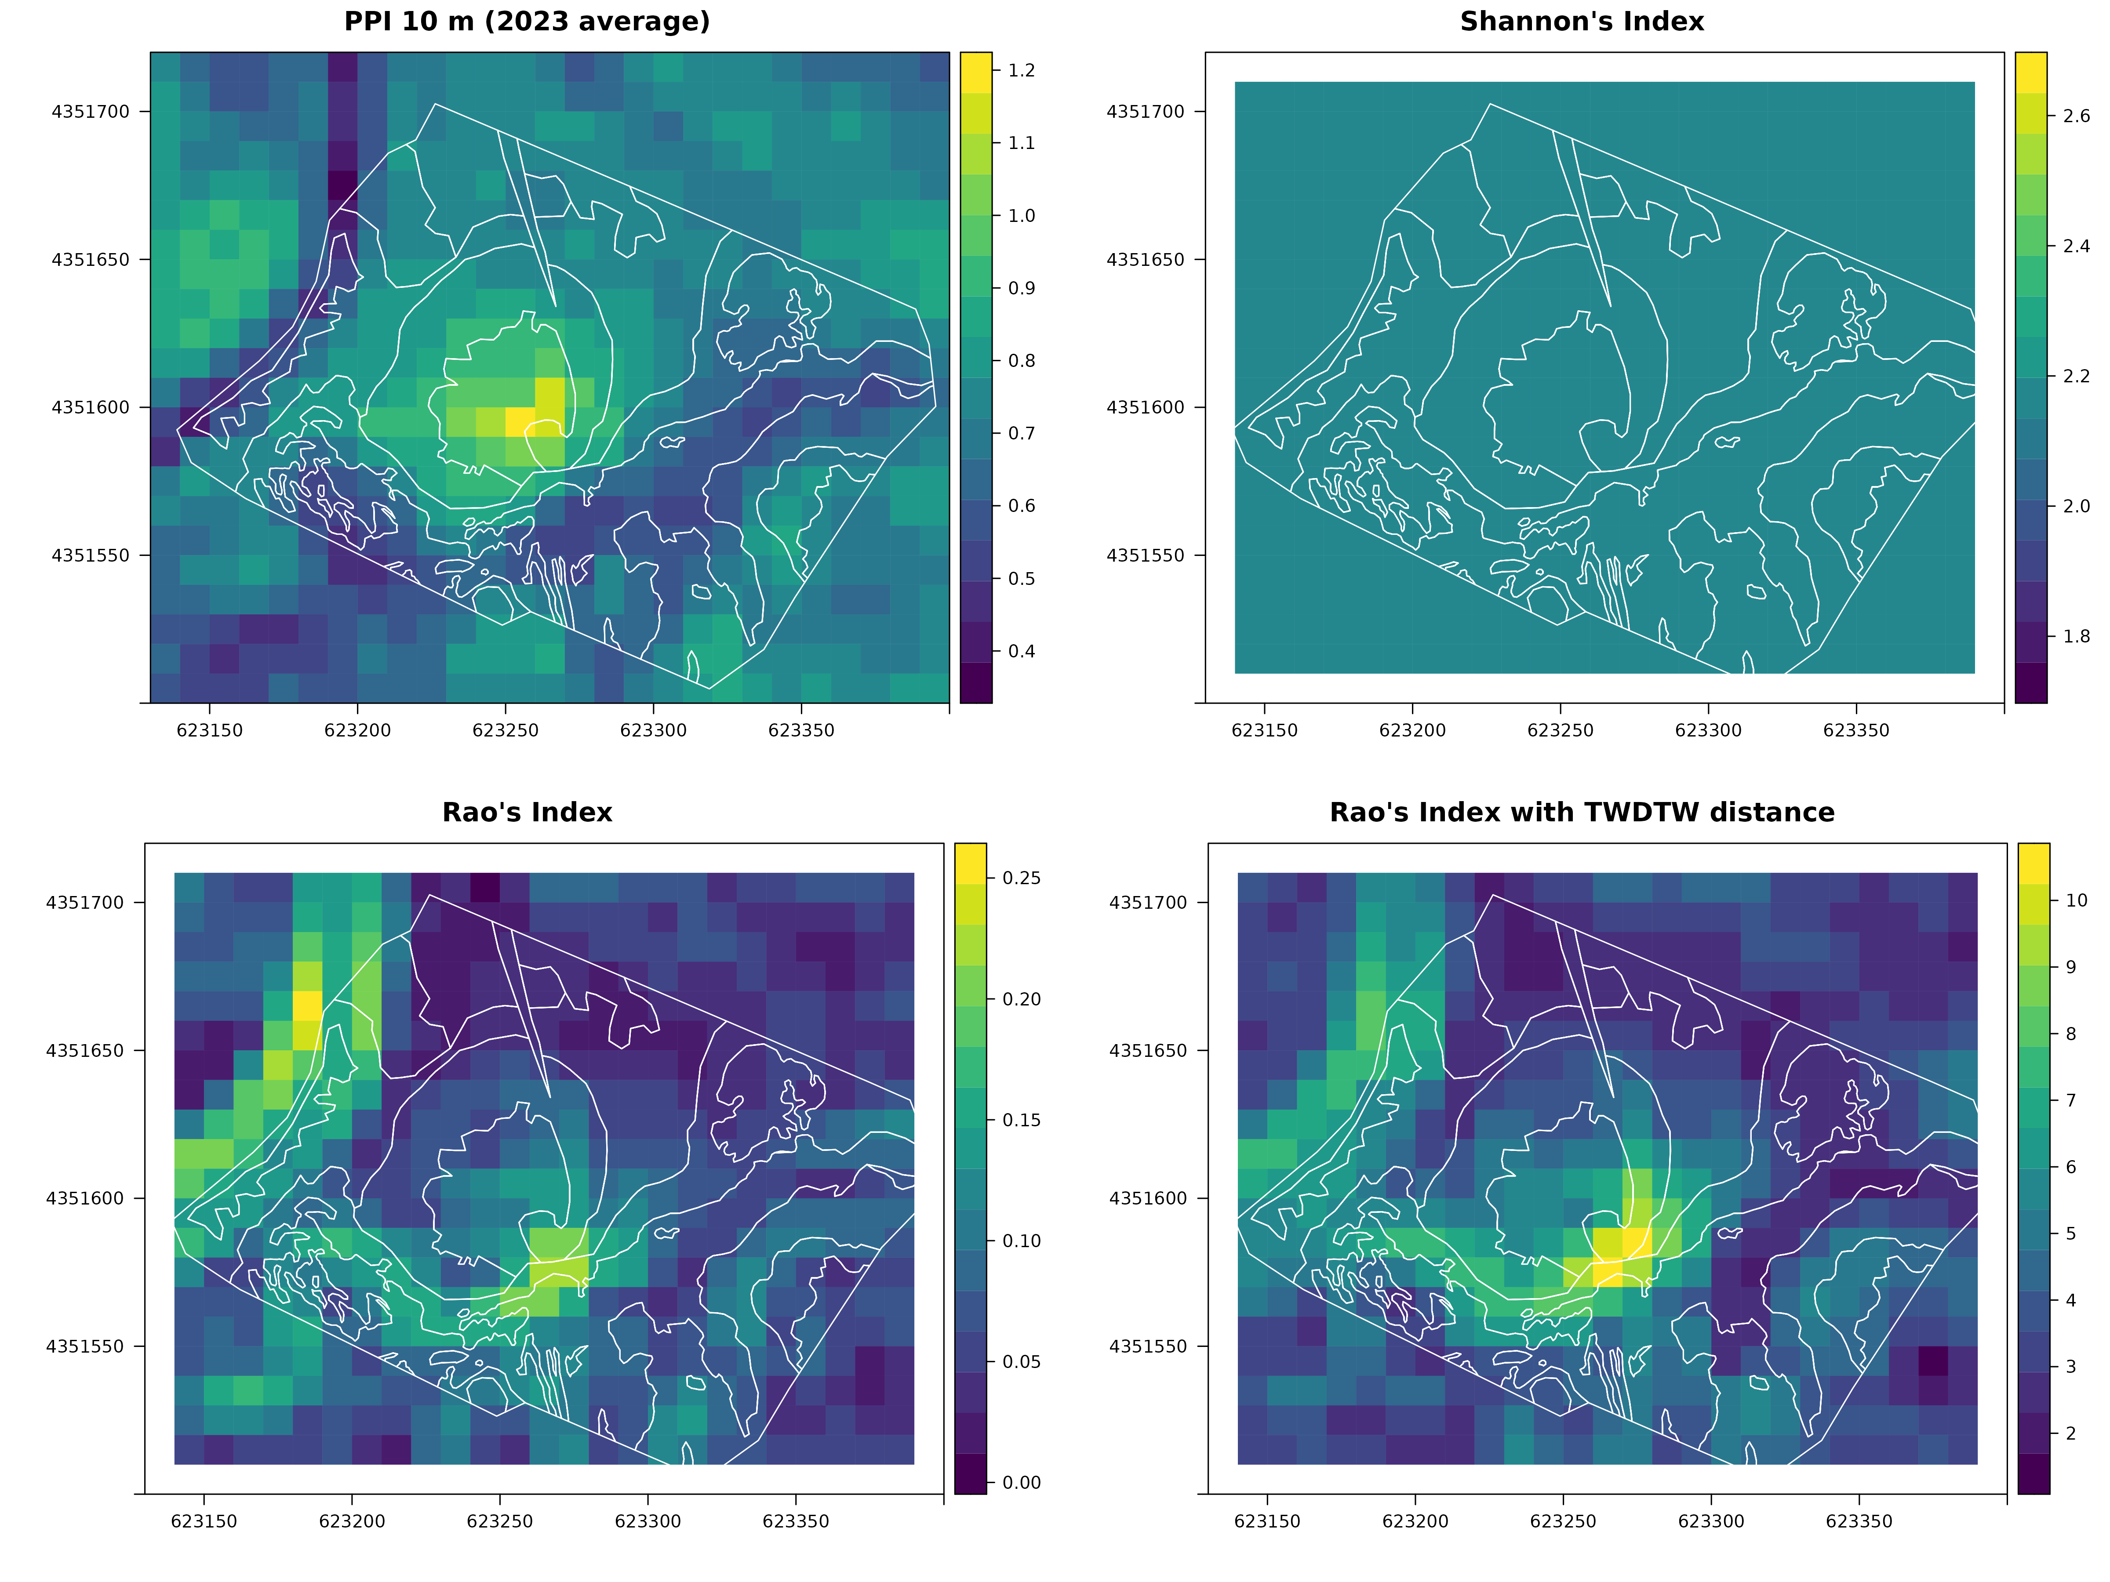
Figure 3: A four panel plot comparing the efficacy of different diversity indices at measuring biodiversity within our grassland ecosystem in Calabria. The white contour lines represent different plant communities classified by an expert botanist from the drone high-resolution image. The scale bar to the right of each plot indicates the assessed biodiversity value in the index being tested (e.g. Shannon’s H index or Rao’s Quadratic Diversity index).

Postprint Methodology:
In this study we used Rao’s Quadratic Diversity Index, augmented with a Time-Weighted Dynamic Time Warping algorithm to differentiate land-use types in three (3) markedly distinct environments, and subsequently assessed the performance of our approach compared to previous implementations of Rao’s Q without TWDTW. We decided upon our selected study sites as each represented a unique opportunity to test different benefits of the approach. Ground-truthing of the Macchia Sacra site conducted during our pilot study (Shayle et al., 2024) provided very detailed land-use coverage data, which allowed us to test this method’s ability to differentiate between multiple similar land-use types common to the European countryside. Given the established literature describing TWDTW’s ability to differentiate agricultural and undisturbed environments, we also opted to include The Knepp estate in the United Kingdom in our analyses. The Knepp Estate is a well characterised (Dempsey, 2021; Schulte to Bühne et al., 2022) former farm which was given over to rewilding purposes in the early 2000’s. It has become a leading case study for researchers and advocates of rewilding in the United Kingdom. Whilst previous studies (Schulte to Bühne et al., 2022) have already assessed the progress of rewilding at this site, they did so only in comparison to the initial state of the estate immediately after agriculture ceased. We have conducted a time series of analyses assessing the ability of Rao’s Q with TWDTW to delineate the rewilded site and assess the progress of rewilding through time. Lastly, our choice of the Mount Kilimanjaro national park in Tanzania is to test this method’s efficacy in one of the world’s most valuable biodiversity hotspots. Situated in Sub-Saharan Africa, the site represents an important case-study to demonstrate the effectiveness of this method in a tropical and mountainous region, a global biodiversity hotspot, and also in a region where (due to inaccessibility and financial factors) traditional in-person ecosystem assessments are not always possible. We also assessed the performance of this approach to monitor the shifting distribution of invasive tree species in the National Park (Delavaux et al., 2023).

Study Sites:

Macchia Sacra, Italy:
The study site was a small (6 hectare) area within the protected area of “Macchia Sacra” (Site of Community Importance (SCI): SICIT9310073). It was selected as it was suitable for thorough imaging by drone, which formed the basis of our ground-truthed biodiversity observations. After drone image acquisition, we defined eight types of plant communities within the study site, with the expertise in classification imparted by an expert botanist (Figure 1). The study site is characterized by the presence of a road on the north-east part of the site. From the level of the road the elevation declines to a lower part which features a sharp canyon running south to west, the result of a previous small stream which had dried up by the time of our drone survey. This part of the study site is characterized by hydrophilic vegetation. Between these two extremes is a small hill which culminates in a plateau. The plateau is the resting area of a herd of cows which graze in the area. This area is much dryer and subject to strong pasture pressure and mechanical disruption, but is more nutrient which, due to the presence of cow manure.
Figure 1: A true colour RGB satellite image (Map data: Google, Maxar Technologies 2023) giving an overview of the study site and its surroundings within Calabria. The eight different plant community types are overlaid as differently coloured masks in transparency upon the image. The subset of the study site which was extracted from Sentinel-2 data is indicated within the red rectangle.

Knepp Estate, United Kingdom:

Kilimanjaro National Park, Tanzania:

Data Preprocessing:

Analytical Approach:

Postprint Results:

Distinguishing Land-use Types in Macchia Sacra, Italy:

Monitoring Rewilding of the Knepp Estate, United Kingdom:

Assessing Land-use Type Diversity in Kilimanjaro National Park, Tanzania:

Preprint Discussion:
In this Hackathon, we developed a streamlined method for implementing the TWDTW algorithm to calculate Rao’s Quadratic Diversity index within the rasterdiv R package. This addition introduces a solid method to account for the temporal dimension to the traditional spatial analysis of landscape diversity. Recognising the dynamic nature of plant communities and ecosystems over time, our method integrates phenological variation into diversity assessments derived from satellite imagery. Notably, our case study found that when this technique was applied to multiband remotely sensed data from disturbed grasslands, accounting for phenological cycles can improve diversity indices by filtering out artefacts. For instance, it can help to distinguish between semi-natural habitats and artificial land cover types, like roads, which lack temporal phenological shifts. These artificial features tend to form clusters of minimal DTW distances when considering DTW as an inter-voxel distance, leading to lower values of Rao’s Q which more accurately reflect their level of biodiversity.
In healthy, biodiverse ecosystems, a variety of flora are also likely to be present to fully utilise the various niches present in the landscape. As Figure 2 from our case study demonstrated, phenology trends can differ substantially within an ecosystem to reflect its biodiversity. PPI rose sharply across the whole site before reaching a peak ranging from approximately 1 to 3 in June, after which point, the site wide PPI drops sharply, mostly remaining between 0.2 and 1 for the rest of the year. As this sharp rise indicates, any analysis based on a single temporal snapshot is likely to be unrepresentative of how the ecosystem in question functions throughout the year. This primary spike in PPI also presents the widest observed range in PPI values, which enables biodiversity indices to better classify the different types of floral communities present. Furthermore, Figure 2 highlights two interesting secondary PPI peaks: one in spring prior to the primary spike in PPI, and the other beginning in October and continuing throughout the winter. Though neither peak is as consistent side wide nor presents the same magnitude of increase in PPI, they are nevertheless ecologically significant. These secondary peaks likely represent floral communities which are exploiting different temporal niches, and like an oasis in the desert, likely also create unique niches to support a more biodiverse ecosystem. Again, an analytical approach which does not consider phenology would misrepresent the functioning of the ecosystem. Additionally, using a traditional DTW approach to consider phenology would erase ecological detail, as the smaller secondary peaks would have been warped to match the rest of the site. Thus, our approach using TWDTW can provide a valuable new level of insight into ecosystem functioning and biodiversity.
Remote sensing via Earth observation remains a rapidly developing area of scientific research with wide applicability to conservation practice (Pettorelli, Safi, and Turner 2014). As the technologies continue to mature, the possibilities remote sensing approaches like ours offer continues to grow. For instance, Schulte to Bühne et al (Schulte to Bühne et al. 2022) recently demonstrated the power of Earth observation satellites to assess rewilding efforts at the landscape scale. Rewilding programmes are notoriously challenging technically, and are often expensive, too. Thus, the ability to assess the progress of rewilding inexpensively at the landscape scale via satellite is eminently valuable. However, as Maus et al (V. Maus et al. 2016) observed, markedly different land use types, such as soy bean plantations and primary rainforest, can be erroneously classified as the same via an NDVI based classification protocol which does not consider phenology. Multiple studies (V. Maus et al. 2016; Lopes et al. 2020) also found that accounting for the effects of phenology significantly increased the accuracy of land use classifications. As rewilding and reforestation programmes continue, our implementation of TWDTW reduces the barrier for conservationists trying to assess the temporal dimension of diversity in addition to the spatial dimension. Our case study further demonstrated that incorporation of phenological data enhances the inferential power of analyses, as this dimension more accurately identified biodiversity hotspots than Rao’s Q index alone (Figure 3). Since increasing biodiversity is typically a core goal of rewilding programmes, of which land cover diversity is a core component (Skidmore et al. 2015), more accurate classification of landscape diversity can highlight where efforts are succeeding or where further efforts are needed.

Postprint Discussion:

Preprint Conclusion:
By incorporating temporal dynamics into the paRao() function of the rasterdiv R package, we broaden the scope for analysing remotely sensed time series. This advancement enriches the suite of diversity indices obtainable from remote sensing data, enhancing our understanding of landscape heterogeneity, and in so doing, enhancing our ability to conserve it.

Postprint Conclusion:

Preprint GitHub & Data Repositories:
This manuscript, previous revisions, open source data, and scripts can all be found on the open source GitHub repository “Samuel-Green/B-3-Hackathon-Project-6” via the URL: https://github.com/Samuel-Green/B-3-Hackathon-Project-6. The implementation of the Rao’s Q index described in this manuscript can be found via the URL: https://github.com/mattmar/rasterdiv/tree/bcubed_hackathon

Preprint Acknowledgements:
We thank:
- Dr. Quentin Groom of Meise Botanic Garden for co-ordinating the project.
- Laura Abraham of Meise Botanic Garden for organising the event.
- Prof. Nicodemo Passalacqua (University of Calabria) who kindly shared the ground-truthing data within pilot project 2.3.2 of the Tech4you PNRR project.
- The European Union’s Horizon Europe Research and Innovation Programme (ID No 101059592) for funding the B-Cubed programme, and thus, this event.
- The Research Foundation - Flanders (FWO) and KU Leuven for the support they gave us in making this event possible.

Preprint References:
Fitchett, Jennifer M, Stefan W Grab, and Dave I Thompson. 2015. “Plant phenology and climate change: Progress in methodological approaches and application.” Progress in Physical Geography: Earth and Environment 39 (4): 460–82. https://doi.org/10.1177/0309133315578940.
Frazier, Amy E., and Benjamin L. Hemingway. 2021. “A Technical Review of Planet Smallsat Data: Practical Considerations for Processing and Using PlanetScope Imagery.” Remote Sensing 13 (19). https://doi.org/10.3390/rs13193930.
Fu, Yongshuo H, Shilong Piao, Xuancheng Zhou, Xiaojun Geng, Fanghua Hao, Yann Vitasse, and Ivan A Janssens. 2019. “Short photoperiod reduces the temperature sensitivity of leaf ‐ out in saplings of Fagus sylvatica but not in horse chestnut,” no. February: 1696–1703. https://doi.org/10.1111/gcb.14599.
Karkauskaite, Paulina, Torbern Tagesson, and Rasmus Fensholt. 2017. “Evaluation of the Plant Phenology Index (PPI), NDVI and EVI for Start-of-Season Trend Analysis of the Northern Hemisphere Boreal Zone.” Remote Sensing 9 (5): 485.
Lopes, Mailys, Pierre-Louis Frison, Sarah M. Durant, Henrike Schulte to Bühne, Audrey Ipavec, Vincent Lapeyre, and Nathalie Pettorelli. 2020. “Combining Optical and Radar Satellite Image Time Series to Map Natural Vegetation: Savannas as an Example.” Remote Sensing in Ecology and Conservation 6 (3): 316–26. https://doi.org/10.1002/rse2.139.
Mace, Georgina M, Ken Norris, and Alastair H Fitter. 2012. “Biodiversity and ecosystem services: a multilayered relationship.” Trends in Ecology & Evolution 27 (1): 19–26. https://doi.org/10.1016/j.tree.2011.08.006.
Marcantonio, Matteo, Elisa Thouverau, and Duccio Rocchini. 2024. “The Rasterdiv Package for Measuring Diversity from Space,” February. https://doi.org/10.1101/2024.02.07.579266.
Maus, V, G Câmara, R Cartaxo, A Sanchez, F M Ramos, and G R de Queiroz. 2016. “A Time-Weighted Dynamic Time Warping Method for Land-Use and Land-Cover Mapping.” IEEE Journal of Selected Topics in Applied Earth Observations and Remote Sensing 9 (8): 3729–39. https://doi.org/10.1109/JSTARS.2016.2517118.
Maus, Victor. 2023. Twdtw: Time-Weighted Dynamic Time Warping. https://CRAN.R-project.org/package=twdtw.
Pettorelli, Nathalie, Kamran Safi, and Woody Turner. 2014. “Satellite remote sensing, biodiversity research and conservation of the future.” Philosophical Transactions of the Royal Society B: Biological Sciences 369 (1643): 20130190. https://doi.org/10.1098/rstb.2013.0190.
Rocchini, Duccio, Matteo Marcantonio, and Carlo Ricotta. 2017. “Measuring Rao’s Q diversity index from remote sensing: An open source solution.” Ecological Indicators 72: 234–38. https://doi.org/10.1016/j.ecolind.2016.07.039.
Rocchini, Duccio, Elisa Thouverai, Matteo Marcantonio, Martina Iannacito, Daniele Da Re, Michele Torresani, Giovanni Bacaro, et al. 2021. “rasterdiv—An Information Theory tailored R package for measuring ecosystem heterogeneity from space: To the origin and back.” Methods in Ecology and Evolution 12 (6): 1093–1102. https://doi.org/10.1111/2041-210X.13583.
Schulte to Bühne, Henrike, Bethany Ross, Christopher J Sandom, and Nathalie Pettorelli. 2022. “Monitoring rewilding from space: The Knepp estate as a case study.” Journal of Environmental Management 312: 114867. https://doi.org/10.1016/j.jenvman.2022.114867.
Skidmore, Andrew K, Nathalie Pettorelli, Nicholas C Coops, Gary N Geller, Matthew Hansen, Richard Lucas, Caspar A Mücher, et al. 2015. “Environmental science: Agree on biodiversity metrics to track from space.” Nature 523 (7561): 403–5. https://doi.org/10.1038/523403a.
Zhang, Yixin, Zhenhong Wang, Yonglong Lu, and Li Zuo. 2022. “Editorial: Biodiversity, Ecosystem Functions and Services: Interrelationship with Environmental and Human Health.” Frontiers in Ecology and Evolution 10. https://doi.org/10.3389/fevo.2022.1086408.

Postprint References:
Botta-Dukát, Z. (2005). Rao’s quadratic entropy as a measure of functional diversity based on multiple traits. Journal of Vegetation Science, 16(5), 533–540. https://doi.org/https://doi.org/10.1111/j.1654-1103.2005.tb02393.x
Delavaux, C. S., Crowther, T. W., Zohner, C. M., Robmann, N. M., Lauber, T., van den Hoogen, J., Kuebbing, S., Liang, J., de-Miguel, S., Nabuurs, G.-J., Reich, P. B., Abegg, M., Adou Yao, Y. C., Alberti, G., Almeyda Zambrano, A. M., Alvarado, B. V., Alvarez-Dávila, E., Alvarez-Loayza, P., Alves, L. F., … Maynard, D. S. (2023). Native diversity buffers against severity of non-native tree invasions. Nature, 621(7980), 773–781. https://doi.org/10.1038/s41586-023-06440-7
Dempsey, B. (2021). Everything under control? Comparing Knepp Estate rewilding project with “traditional” nature conservation. PLoS ONE, 16(6 June), 1–24. https://doi.org/10.1371/journal.pone.0241160
Fu, Y. H., Piao, S., Zhou, X., Geng, X., Hao, F., Vitasse, Y., & Janssens, I. A. (2019). Short photoperiod reduces the temperature sensitivity of leaf-out in saplings of Fagus sylvatica but not in horse chestnut. Global Change Biology, 25(5), 1696–1703. https://doi.org/10.1111/gcb.14599
Klosterman, S. T., Hufkens, K., Gray, J. M., Melaas, E., Sonnentag, O., Lavine, I., Mitchell, L., Norman, R., Friedl, M. A., & Richardson, A. D. (2014). Evaluating remote sensing of deciduous forest phenology at multiple spatial scales using PhenoCam imagery. Biogeosciences, 11(16), 4305–4320. https://doi.org/10.5194/bg-11-4305-2014
Mace, G. M., Norris, K., & Fitter, A. H. (2012). Biodiversity and ecosystem services: a multilayered relationship. Trends in Ecology & Evolution, 27(1), 19–26. https://doi.org/https://doi.org/10.1016/j.tree.2011.08.006
Madonsela, S., Cho, M. A., Ramoelo, A., & Mutanga, O. (2017). Remote sensing of species diversity using Landsat 8 spectral variables. ISPRS Journal of Photogrammetry and Remote Sensing, 133, 116–127. https://doi.org/https://doi.org/10.1016/j.isprsjprs.2017.10.008
Maus, V. (2023). twdtw: Time-Weighted Dynamic Time Warping. https://cran.r-project.org/package=twdtw
Maus, V., Câmara, G., Cartaxo, R., Sanchez, A., Ramos, F. M., & Queiroz, G. R. de. (2016). A Time-Weighted Dynamic Time Warping Method for Land-Use and Land-Cover Mapping. IEEE Journal of Selected Topics in Applied Earth Observations and Remote Sensing, 9(8), 3729–3739. https://doi.org/10.1109/JSTARS.2016.2517118
Pettorelli, N., Safi, K., & Turner, W. (2014). Satellite remote sensing, biodiversity research and conservation of the future. Philosophical Transactions of the Royal Society B: Biological Sciences, 369(1643), 20130190. https://doi.org/10.1098/rstb.2013.0190
Rocchini, D. (2007). Effects of spatial and spectral resolution in estimating ecosystem α-diversity by satellite imagery. Remote Sensing of Environment, 111(4), 423–434. https://doi.org/https://doi.org/10.1016/j.rse.2007.03.018
Rocchini, D., Marcantonio, M., & Ricotta, C. (2017). Measuring Rao’s Q diversity index from remote sensing: An open source solution. Ecological Indicators, 72, 234–238. https://doi.org/https://doi.org/10.1016/j.ecolind.2016.07.039
Rocchini, D., Thouverai, E., Marcantonio, M., Iannacito, M., Da Re, D., Torresani, M., Bacaro, G., Bazzichetto, M., Bernardi, A., Foody, G. M., Furrer, R., Kleijn, D., Larsen, S., Lenoir, J., Malavasi, M., Marchetto, E., Messori, F., Montaghi, A., Moudrý, V., … Wegmann, M. (2021). rasterdiv—An Information Theory tailored R package for measuring ecosystem heterogeneity from space: To the origin and back. Methods in Ecology and Evolution, 12(6), 1093–1102. https://doi.org/https://doi.org/10.1111/2041-210X.13583
Schulte to Bühne, H., Ross, B., Sandom, C. J., & Pettorelli, N. (2022). Monitoring rewilding from space: The Knepp estate as a case study. Journal of Environmental Management, 312, 114867. https://doi.org/https://doi.org/10.1016/j.jenvman.2022.114867
Shannon, C. E. (1948). A mathematical theory of communication. The Bell System Technical Journal, 27(3), 379–423. https://doi.org/10.1002/j.1538-7305.1948.tb01338.x
Shayle, E., Marcantonio, M., Labadessa, R., Richiardi, C., & Vicario, S. (2024). Phenological Diversity Trends with Remote Sensing Datacubes. BioHackrXiv, 1–10. https://doi.org/10.37044/osf.io/pqfws
Torresani, M., Rocchini, D., Sonnenschein, R., Zebisch, M., Marcantonio, M., Ricotta, C., & Tonon, G. (2019). Estimating tree species diversity from space in an alpine conifer forest: The Rao’s Q diversity index meets the spectral variation hypothesis. Ecological Informatics, 52(April), 26–34. https://doi.org/10.1016/j.ecoinf.2019.04.001
Zhang, Y., Wang, Z., Lu, Y., & Zuo, L. (2022). Editorial: Biodiversity, ecosystem functions and services: Interrelationship with environmental and human health. Frontiers in Ecology and Evolution, 10. https://doi.org/10.3389/fevo.2022.1086408

